**Assist Me**



Abstract

Assist Me is an easy good-looking task reminder, it allows you to choose from variety of events and customize your own reminder as you like.

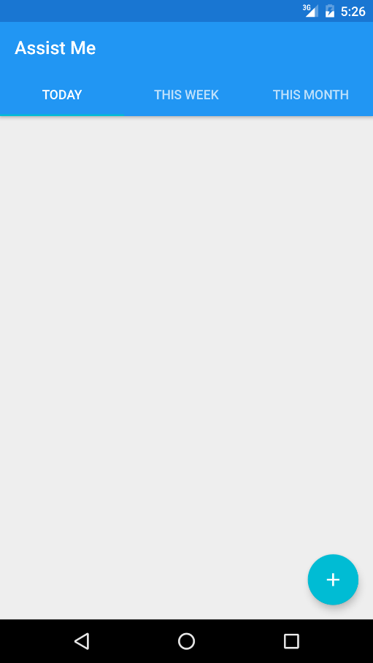

**Opening app**

Assist Me offer three categorizations for your task, Today, This Week and This Month. As the title suggests, each one provides list of tasks.

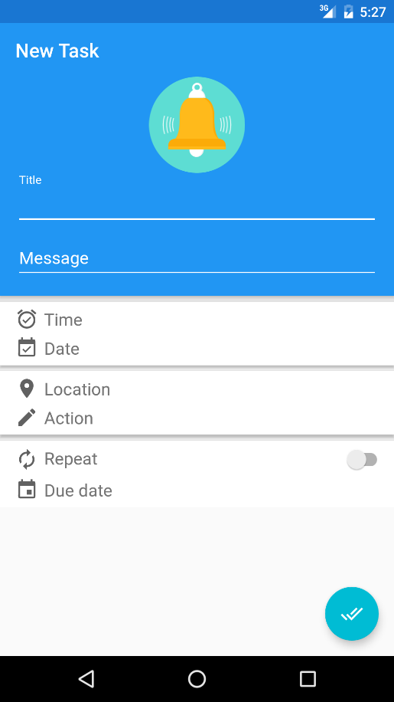

**Creating a task**

By simply touching the plus button the user is redirected to a form where the new task can be created. Every item of that form provides more information about the task.

**Message**

In this field the user provides description or more information to be displayed when being reminded.

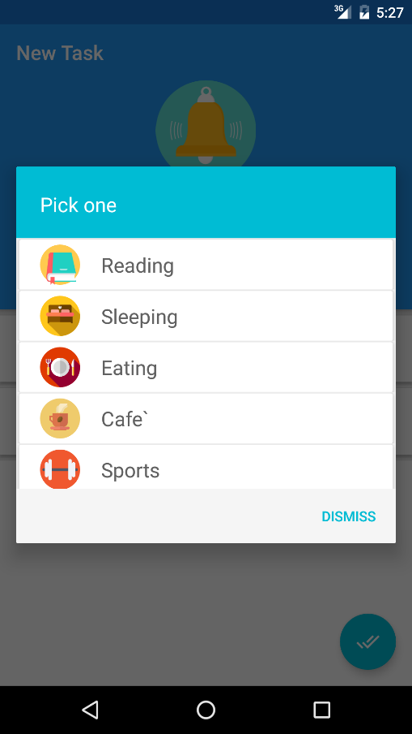

**Choosing a tag**

By clicking the bell icon, a list of pre-defined tasks is provided to choose any of them and then customize its attributes.

Ps. If the user didn’t choose one the app will use that bell tag as a thumbnail by default.

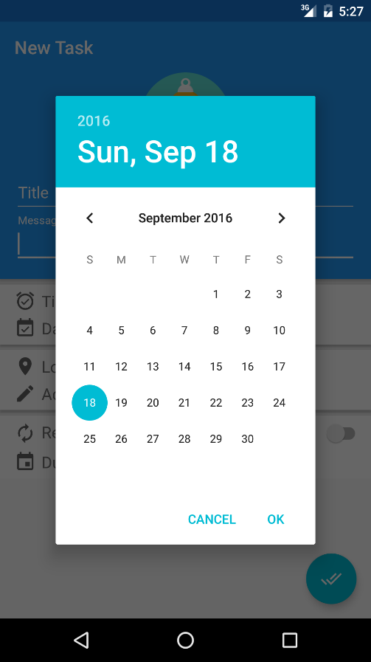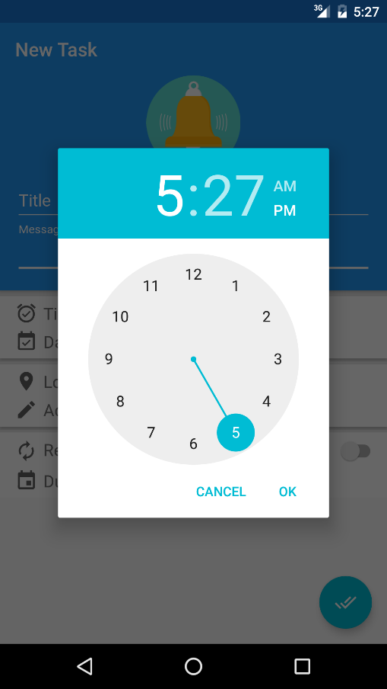

**Time**

Here the user specifies the execution time of the task.

**Date**

Here the user specifies the execution date of the task.

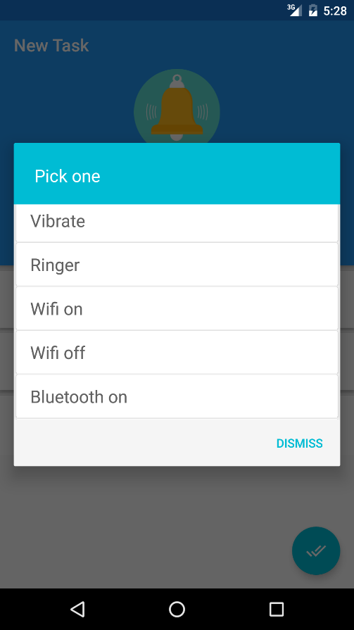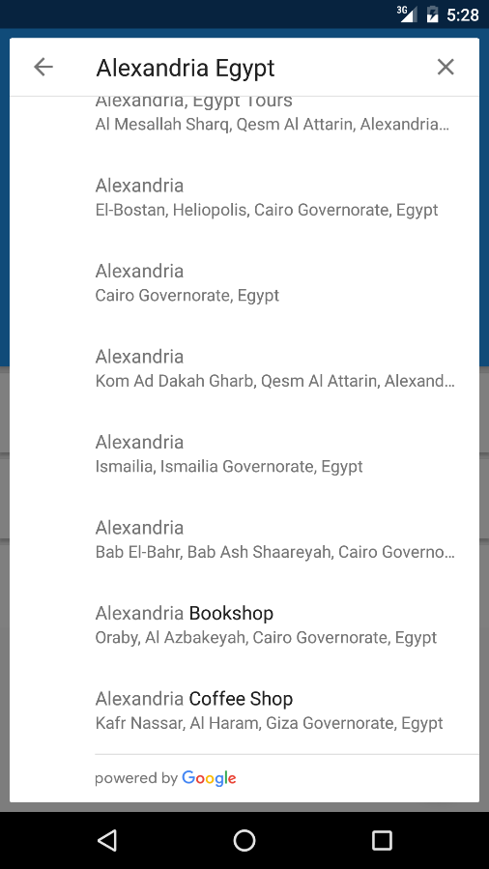

**Location**

This is an optional field to specify the location of the event. The app uses Google’s APIs to provide search results about the specified location.

**Action**

The app allows the user to choose from some actions to be executed automatically when the task is triggered like making the device silent, vibrate, turn Wi-Fi on or off, etc. This is an optional field also.

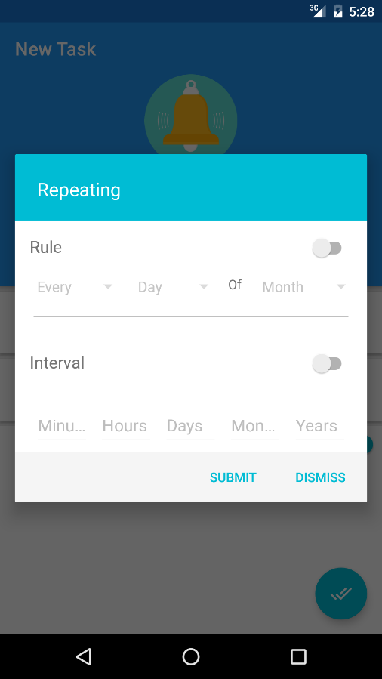

**Repeating**

The app provides repeating execution times for the same task to save the user time and effort. It provides two repeating modes: by rule and on intervals. The by rule mode provides specific day-based choice as every day of month or 2nd Monday of July. The second rule is on interval that provides a specific interval measured by number of minutes, hours, days, months and years starting from the time and date specified previously.

**Due date**

This provides the due date when the repeating task expires.

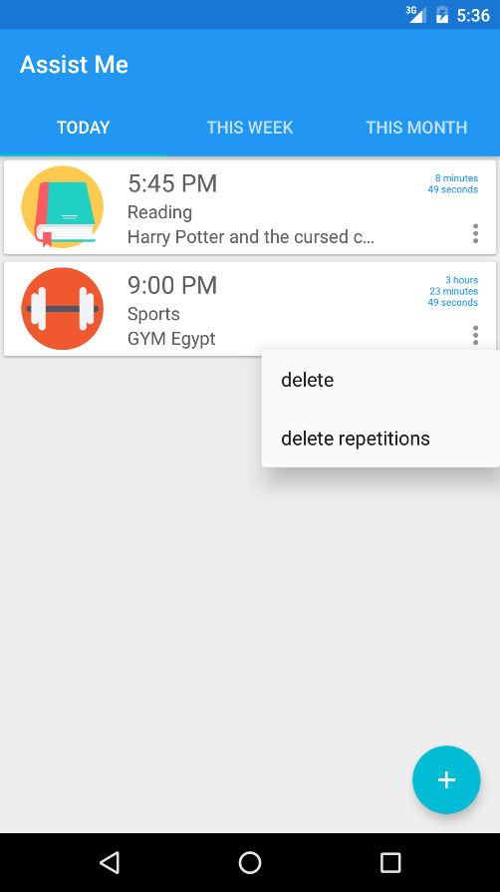

**Provided information**

Each member is providing the time, title and description message of the task alongside with the tag image. Also on the right the remaining time for that task is provided with the popup options menu.

**Popup menu**

The popup menu allows the user to delete the task or delete the repetitions of the task which leaves only the first time of execution and remove all repetitions.

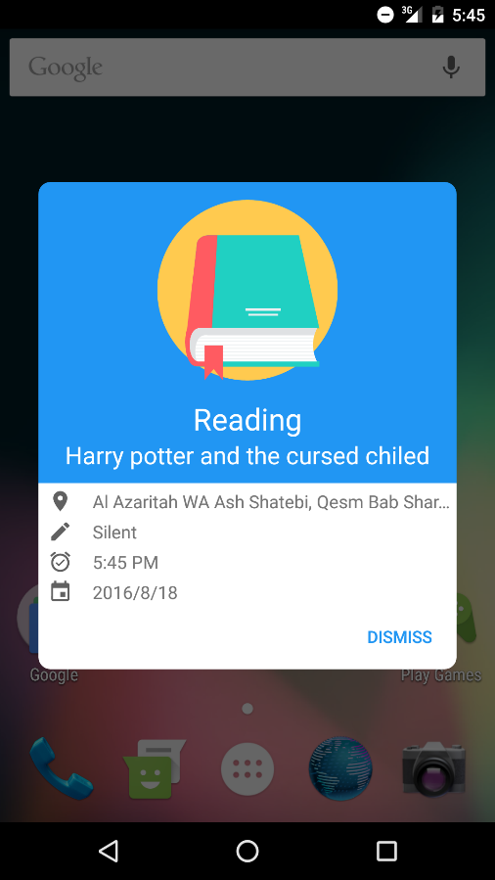

**Finally, the reminding notification**

When task is triggered this notification alert pops up showing some information about the task, and the app executes the action that was specified (if any).

**Notes**

* The application perform full scan on database on every time the device is restarted to clean the tasks that was expired when the device was turned off.
* The task notification pops up on the screen even if the application itself was killed or removed from background apps, so don’t worry about that.
* Tasks are arranged by remaining times in ascending order.
* The UI items are following Google’s material design guidelines to provide enjoyable user experience and support many devices as possible.
* The images used in this app is created under a free license from flat icons designers and some of them are mine.

**Current progress**

* Testing on multiple platforms and devices.
* Performing upgrades on memory and battery resources.
* Supporting more actions to be executed automatically.
* Working on location based tasks beside the time based ones implemented already.

**Developers**

* Amr Gamal Mohammed